**COURSE TITLE: DATABASE**

**PROJECT TITLE: FLIGHT RESERVATION SYSTEM**



**Lahore Garrison University**

**Submitted To:**

**Submitted By:**

Ma’am Sadia Zafar

Section – A

Khawaja Azfar Asif SP2020-BSSE-023

kjkjk

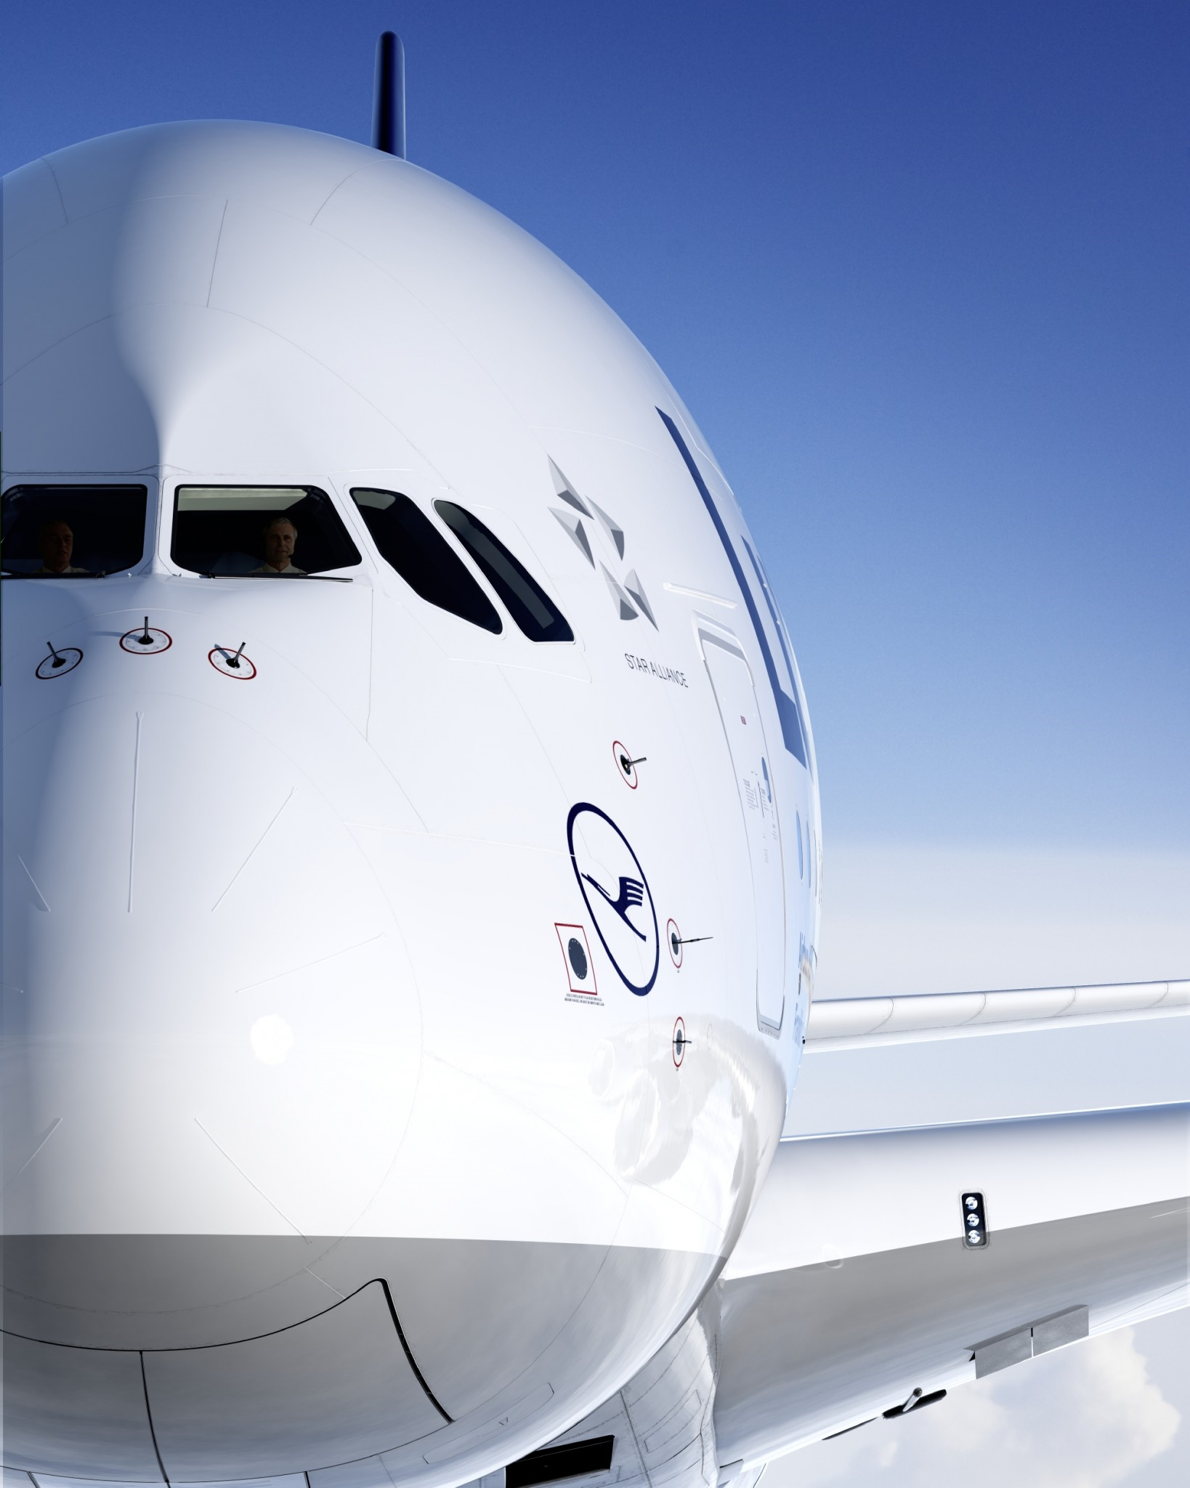

# 

# 

# TABLE OF CONTENTS

1.Introduction

1.1 Introduction of project

1.2 Project Statement

2. Class Diagram

2.1 Class Diagram

3.Entity Table

3.1 Entity Table

4. Requirement

4.1 System Requirements

5. SQL Code

5.1 SQL Code

6. Questions

6.1 Questions

7. ERD

7.1 ERD

# CHAPTER 1

INTRODUCTION

The relations that are made are shown in the ERD and these relations are made by thinking carefully. According to these relations Flight manager will manage Flights and Travelers. The Travelers will take Flight and will travels on the airplane. Our project has an additional feature which is that airplane management will serve a meal to its attendants.

The flight table contains information about flight number, Departure Location date and time, Arrival location date and time, flight status like the flight is delayed or not, flight type that the flight is connecting or direct and this table has a foreign key of the admin and the airplane.

The Airplane table contains Air Bus no, Air bus Type like domestic or the foreign, Airline name what is the name of the airline, seats the seating capacity of the airplane and this table has a flight duration as the foreign key. It will help us to know which type of food will be served.

The traveler table contains information about first name, last name , address of the person , id card number , reservation status whether the ticket is purchased or booked, and this table has a foreign key of the admin table which will let us know about the admin that who is managing , Airplane table which will tell on which airplane he/she is travelling and the Flight table that will tell all the information about the flight.

The admin table contains the information about the first name, last name, age and telephone number of the admin of that airport that are managing and observing the flights.

The Meal table includes the int number as the primary key that will return the meal type to the airplane. The data entered in our system is according to only use of the one airport like the departures location is Lahore and the arrival location is change for every flight and nothing is repeated. So, we can say that this database system can be used by only one airport. We can take an example that this project is just a demo made for of the Alama Iqbal International Airport Lahore. As the flight management is very technical and broad so that it will have many details that will make our project very difficult and lengthy. We have used only 9 flights and 7 airplanes in our data and almost 90 entries are made for the travelers. There are five meal types and four admins used in our data. These entries are dependent on the present time frame and the data entered is very recent.

The project is not unique from others there will be just difference of the data distribution and the data entered or some entities will be less or more from the other project as this project is made without any help from any previous project made on this. The only uniqueness that we can claim is that this is 100% made from scratch without seeing any content related to this.

PROJECT STATEMENT

PROBLEM STATEMENT

The Airplane Company wants System for them because there are many problems in existing systems like

* Manpower
* High cost
* Time and speed
* Security
* Complexity
* Maintenance
* Accuracy
* Storing
* Records might get lost

OBJECTIVES

* SAVE TIME

Data entry with the help of our system will be very easy which will save huge amount of time

* GRAPHICAL USER INTERFACE

User can view products in effective graphical user interface.

* SAVE ENERGY

This will help in saving the energy and fuel needed to do shopping by going to the shops.

* USER FRIENDLY

The system will be easy to understand since it will be user friendly.

CHAPTER 2

CLASS DIAGRAM

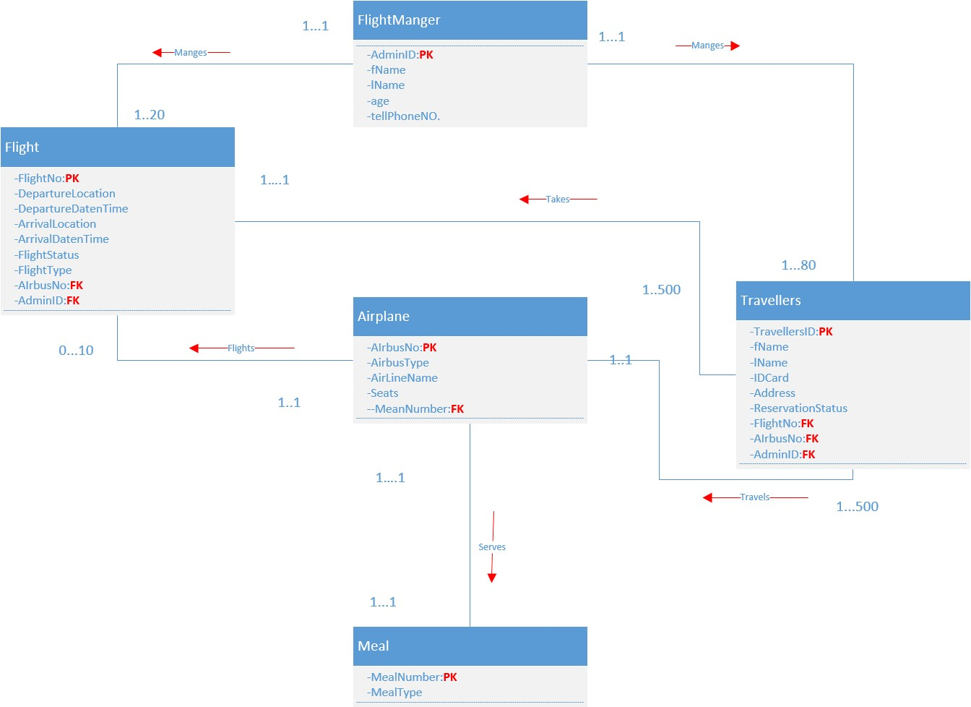

CHAPTER 3

ENTITY TABELE

|  |  |  |  |
| --- | --- | --- | --- |
| Entity / Table Name | Primary key | No. of Attributes | No. of records |
| Login | AdminID | 2 | 4 |
| Flight manager | AdminID | 6 | 4 |
| Flight | FlightNo | 9 | 10 |
| Airplane | AirBusNo | 5 | 10 |
| Meal | MealNumber | 2 | 5 |
| Travellers | TravelersID | 10 | 100 |

CHAPTER 4

REQUIREMENTS

HARDWARE COMPONENTS

* Processor – i3
* Hard Disk – 5 GB
* Memory – 1GB RAM

SOFTWARE REQUIRMENTS

* Windows Xp, Windows 7(ultimate, enterprise)
* Sql 2008

CHAPTER 5

SQL CODE

Create Database Project;

Use Project;

**-------------Login Table----------------**

**Create Table Login**

(

AdminID varchar (5) primary key,

Password varchar (15),

);

**---------------Triggers-------------**

**CREATE TRIGGER**

NEW_ADMIN_ADD on Login

After Insert as

begin print 'New Admin Added'

end;

**CREATE TRIGGER**

Admin_Delete on Login

After Delete as

begin print 'Admin Deleted'

end;

**CREATE TRIGGER**

Admin_Updated on Login

After Update as

begin print 'Admin Updated'

end;

**Insert into Login values**

('Fm001', '12345'),

('Fm002', '54321'),

('Fm003', '13579'),

('Fm004', '24680');

Select * from Login;

**-----------------------Test Data-------------------------------**

Insert into Login values ('Fm122', '123@#$#6');

Select * from Login;

Update Login SET Password='43534! @$#11111' where AdminID='Fm122';

Delete from Login where AdminID='Fm122';

Select * from Login;

Select * from Travellers;

**-----------Flight Manager Table--------------**

**Create Table FlightManager**

(

AdminID varchar (5) primary key,

FName varchar (15) not null,

LName varchar (15),

Age int check(age>=18) not null,

TellNo varchar (15),

Password varchar (15)

);

**---------------Triggers-------------**

**CREATE TRIGGER**

New_FlightManager_ADD on FlightManager

After Insert as

begin print 'New FlightManager Added'

end;

**CREATE TRIGGER**

FlightManager_Delete on FlightManager

After Delete as

begin print 'FlightManager Deleted'

end;

**CREATE TRIGGER**

FlightManager_Updated on FlightManager

After Update as

begin print 'FlightManager Updated'

end;

**Insert into FlightManager values**

('Fm001','Azfar','Asif’, 21,'03211-841227', '12345'),

('Fm002','Abdul','Rehman’, 35,'0309-6124112', '54321'),

('Fm003','Muzzamil','Habib',20,'0322-8123441', '13579'),

('Fm004','Muhammad','Asad', 23,'0345-9188221', '24680');

Select * from FlightManager;

Drop Table FlightManager;

**---------------------------Views for ALL DATA from Login & Flight Manager table----------------------**

SELECT L. ADMINID, L. PASSWORD, F. ADMINID, F. FNAME, F. LNAME FROM LOGIN L FULL OUTER JOIN FlightManager F ON L. ADMINID =F. ADMINID

**-----------------------------Test Data--------------------------------------------**

Insert into FlightManager values ('Fm324','Junaid','Asif’, 71,'03211-841227', '12@R$%45');

Select * from FlightManager;

Update FlightManager SET Password='43534! @$#11111' where AdminID='Fm324';

Select * from FlightManager;

Delete from FlightManager where AdminID='Fm324';

Select * from FlightManager;

**------------AirPlane Table-----------------**

**Create Table AirPlane**

(

AirBusNo varchar (5) primary key,

AirBusType varchar (15) check (airbustype ='domestic’ or airbustype ='foreign'),

AirlineName varchar (40) not null,

Seats int check(seats>0 and seats<500) not null,

MealNumber int foreign key references Meal (MealNumber) not null

);

**--------------Triggers-----------**

**CREATE TRIGGER**

New_AirPlane_ADD on AirPlane

After Insert as

begin print 'New AirPlane Added'

end;

**CREATE TRIGGER**

AirPlane_Delete on AirPlane

After Delete as

begin print 'AirPlane Deleted'

end;

**CREATE TRIGGER**

AirPlane_Updated on AirPlane

After Update as

begin print 'AirPlane Updated'

end;

**Insert into AirPlane values**

('Sh225','Domestic', 'Shaheen',100,1),

('Pia12','Domestic', 'Pakistan International Airline',120,4),

('Qtr12','Foreign’, ‘Qatar Airlines',300,2),

('Emr11','Foreign’, ‘Emirates',320,2),

('Ab123','Domestic', 'Air Blue',150,1),

('Sa123','Foreign’, ‘Saudi Airline',250,2),

('As123','Foreign’, ‘AirSian',250,5),

('TK714','Foreign’, ‘Turkish Airline',250,2),

('DAL12','Foreign’, ‘Delta Air Lines',250,5),

('BA12', 'Foreign’, ‘British Airways',300,2);

Drop Table AirPlane;

Select * from AirPlane;

**------------------Test Data----------------------------------------------**

Insert into AirPlane values ('xyx','Domestic', 'lolo',100,1);

Select * from AirPlane;

Update AirPlane SET AirBusType='Foreign' where AirBusNo='xyx';

Select * from AirPlane;

Delete from AirPlane where AirBusNo='xyx';

Select * from AirPlane;

**-----------------------Join to see FlightManger, Airplanr-----------------------------------**

SELECT F. ADMINID, F. FNAME, F. LNAME, A. AIRBUSNO, A. AIRBUSTYPE FROM FlightManager F FULL OUTER JOIN AirPlane A ON F. ADMINID= A. AIRBUSNO

**-----------------Meal Table--------------------**

**Create Table Meal**

(

MealNumber int primary key NOT NULL,

MealType varchar (30)

);

**-----------Triggers----------**

**CREATE TRIGGER**

New_Meal_ADD on Meal

After Insert as

begin print 'New Meal Added'

end;

**CREATE TRIGGER**

Meal_Delete on Meal

After Delete as

begin print 'Meal Deleted'

end;

**CREATE TRIGGER**

Meal_Updated on Meal

After Update as

begin print 'Meal Updated'

end;

**Insert into Meal Values**

(1, 'Bevrages with fast food'),

(2, 'CHINESE FOOD'),

(3, 'MEXICAN FOOD'),

(4, 'Biryani with soft drink'),

(5, 'Snacks with soft drink');

Drop Table Meal;

Select * from Meal;

**--------------------------------Test Data----------------------------------------------**

Insert into Meal values (6, 'Food');

Select * from Meal;

Update Meal SET MealType='NO FOOD' where MealNumber='6';

Select * from Meal;

Delete from Meal where MealNumber='6';

Select * from Meal;

**--------------------------Join to see Airplanr, Meal -----------------------------------**

SELECT A. AIRBUSNO, A. AIRBUSTYPE, M. MEALNUMBER, M. MEALTYPE FROM AirPlane A FULL OUTER JOIN Meal M ON A. AIRBUSNO =M. MEALTYPE;

**--------------------Flight Table---------------------**

**Create Table Flight**

(

FlightNo varchar (5) primary key,

DepartureLocation varchar (25) not null,

DeparturedatenTime datetime not null,

ArrivalLocation varchar (25) not null,

ArrivaldatenTime datetime not null,

FlightStatus varchar (25) check (FlightStatus ='Not Delayed’ or FlightStatus='Delayed'),

FightType varchar (25) check (FightType='Connecting’ or FightType='Direct'),

AdminID varchar (5) foreign key references FlightManager (AdminID),

AirBusNo varchar (5) foreign key references Airplane (AirBusNo)

);

**-----------Triggers------------**

**CREATE TRIGGER**

New_Flight_ADD on Flight

After Insert as

begin print 'New Flight Added'

end;

**CREATE TRIGGER**

Flight_Delete on Flight

After Delete as

begin print 'Flight Deleted'

end;

**CREATE TRIGGER**

Flight_Updated on Flight

After Update as

begin print 'Flight Updated'

end;

Select * from Flight;

Drop Table Flight

**Insert into Flight values**

('Fl001','Gilgit-Baltistan','2022-2-17 3:00:00', 'Islamabad','2022-2-17 4:00:00’, ‘Delayed’, ‘Direct’, ‘Fm001','Sh225'),

('Fl002','Gilgit-Baltistan','2022-2-18 12:00:00','USA’, ‘2022-2-18 00:00:00’, ‘Delayed’, ‘Connecting','Fm001','Qtr12'),

('Fl003','Gilgit-Baltistan','2022-2-20 3:00:00', 'Dubai’, ‘2022-2-20 5:30:00’, ‘Not Delayed’, ‘Direct’, ‘Fm002','Emr11'),

('Fl004','Gilgit-Baltistan','2022-2-11 4:00:00', 'Karachi’, ‘2022-2-11 5:30:00’, ‘Not Delayed','Direct’, ‘Fm002','Sh225'),

('Fl005','Gilgit-Baltistan','2022-2-15 12:00:00','China’, ‘2022-2-15 14:00:00', 'Not Delayed','Direct’, ‘Fm003','As123'),

('Fl006','Gilgit-Baltistan','2022-2-22 14:00:00','Saudia’, ‘2022-2-22 17:00:00’, ‘Delayed’, ‘Direct’, ‘Fm003','Sa123'),

('Fl007','Gilgit-Baltistan','2022-2-18 10:00:00','Peshawar', '2022-2-18 11:30:00', 'Not Delayed','Direct’, ‘Fm004','Pia12'),

('Fl008','Gilgit-Baltistan','2022-2-25 15:00:00','Quetta’, ‘2022-2-25 16:30:00', 'Not Delayed','Direct’, ‘Fm004','Ab123'),

('Fl009','Gilgit-Baltistan','2022-2-25 13:00:00','Turkey’, ‘2022-2-25 17:30:00', 'Not Delayed','Direct’, ‘Fm004','TK714'),

('Fl010','Gilgit-Baltistan','2022-2-17 12:00:00','Australia','2022-2-17 18:00:00', 'Not Delayed','Connecting','Fm004','Qtr12');

Select * from Flight;

**--------------------------------Test Data----------------------------------------------**

Insert into Flight values ('Fl999','Gilgit-Baltistan','2022-2-17 3:00:00', 'Islamabad','2022-2-17 4:00:00’, ‘Delayed’, ‘Direct’, ‘Fm001','Sh225');

Select * from Flight;

Update Flight SET DepartureLocation='Lahore' where FlightNo='Fl999';

Select * from Flight;

Delete from Flight where FlightNo='Fl999';

Select * from Flight;

**------------------------Join to see Meal, Flight -----------------------------------**

SELECT M. MEALNUMBER, M. MEALTYPE, F. FlightNo, F. DepartureLocation, F. DeparturedatenTime, F. ArrivalLocation, F. ArrivaldatenTime, F. FlightStatus, F. FightType, F. AdminID, F. AirBusNo FROM Meal M FULL OUTER JOIN Flight F ON M. MEALTYPE=F.FlightNo;

**------------------Travellers Table-----------------------**

**Create Table Travellers**

(

TravellersID varchar (5) primary key,

FName varchar (15) not null,

LName varchar (15),

IDcard varchar (15) not null unique,

Passport varchar (55) not null unique,

Address varchar (1000),

ReservationStatus varchar (8) check (reservationstatus ='booked’ or reservationstatus='paid'),

FlightNo varchar (5) foreign key references Flight (FlightNo),

AirBusNo varchar (5) foreign key references Airplane (AirBusNo),

AdminID varchar (5) foreign key references FlightManager (AdminID)

);

Select * from Travellers;

Drop table Travellers

**----------------------Triggers-----------------------------------------**

**CREATE TRIGGER**

NEW_ADD on Travellers

After Insert as

begin print 'New Travellers Added'

end;

**CREATE TRIGGER**

Traveller_Delete on Travellers

After Delete as

begin print 'Travellers Deleted'

end;

**CREATE TRIGGER**

Traveller_Updated on Travellers

After Update as

begin print 'Travellers Updated'

end;

**Insert into Travellers values**

('Tr001','Munib','Majid','lhr2','lhr1', 'Architect Lahore ‘,'Booked','Fl001','Sh225','Fm001')

**Insert into Travellers values**

('Tr002','Umar','Butt', 'lhr123','lhr2','Punjab Society Lahore','Paid','Fl001','Sh225','Fm002')

**Insert into Travellers values**

('Tr003','Umer','Malik','skp891','lhr3','Central Park SKP','Booked','Fl001','Sh225','Fm001')

**Insert into Travellers values**

('Tr004','Junaid','Farooq','lhr221','lhr4', 'Model Town Block B Lahore','Paid','Fl007','Pia12','Fm003')

**Insert into Travellers values**

('Tr005','Shahreyar','Zaka','lhr981','lhr5','Model Town Block F Lahore','Booked','Fl007','Pia12','Fm002')

**Insert into Travellers values**

('Tr006','Shahryar','Shabbir','lhr781','lhr6', 'Abnerval Multan Chunga Lahore','Booked','Fl008','Ab123','Fm004')

**Insert into Travellers values**

('Tr007','Mahad','Imran','lhr213','lhr7','Punjab Society Lahore','Paid','Fl008','Ab123','Fm004')

**Insert into Travellers values**

('Tr008','Shayan','Rao','lhr571','lhr8','Abdalians Society Lahore','Paid','Fl002','Qtr12','Fm002')

**Insert into Travellers values**

('tr009','zuhair','baig','lhr561','lhr9','revenue society Lahore ','booked','fl007','pia12','fm001')

**Insert into Travellers values**

('Tr010','Rafey','Amir','lhr153','lhr10','Model Block 1 Lahore','Booked','Fl006','Sa123','Fm003')

**Insert into Travellers values**

('Tr011','Shahgil','Jutt','skp871','lhr11','Jinnah Park SKP','Booked','Fl008','Ab123','Fm002')

**Insert into Travellers values**

('Tr012','Shahreyar','Zaka','lhr001','lhr12','Model Town Block F Lahore','Booked','Fl007','Pia12','Fm002')

**Insert into Travellers values**

('Tr013','Usman','Mughal','isl761','lhr13','Secotr F11 Islamabad','Paid','Fl004','Sh225','Fm002')

**Insert into Travellers values**

('Tr014','Peerzada','Ali','isl198','lhr14','Sector A10 Islamabad','Paid','Fl001','Sh225','Fm003')

**Insert into Travellers values**

('Tr015','Imran','Khan','psw912','lhr15','Alirazabad Peshawar','Booked','Fl008','Ab123','Fm004')

**Insert into Travellers values**

('Tr016','Aiza','Ali','khi120','lhr16','Sadar Can’t Karachi','Paid','Fl006','Sa123','Fm004')

**Insert into Travellers values**

('Tr017','Junejo','Khan','isl124','lhr17','Sector G12 Islamabad','Booked','Fl006','Sa123','Fm004')

**Insert into Travellers values**

('Tr018','Ayesha','Ali','khi214','lhr18','Upper Town Karachi','Paid','Fl006','Sa123','Fm001')

**Insert into Travellers values**

('Tr019','David','Scotch','us123','lhr19','California USA','Paid','Fl002','Qtr12','Fm002')

**Insert into Travellers values**

('Tr020','David','Viese','us412','lhr20','Uptown USA','Booked','Fl002','Qtr12','Fm002')

**Insert into Travellers values**

('Tr021','Faisal','Quereshi','khi212','kh1','Liyari Town Karachi','Paid','Fl004','Sh225','Fm001')

**Insert into Travellers values**

('Tr022','Rabia','Faisal','lhr219','kh2','Tariq Garden Lahore','Paid','Fl004','Sh225','Fm004')

**Insert into Travellers values**

('Tr023','DJ','Bravo','wi421','kh3','Kulkarni West Indies','Booked','Fl008','Ab123','Fm003')

**Insert into Travellers values**

('Tr024','Bella','Ciao','us871','kh4','La Down Town USA','Paid','Fl002','Qtr12','Fm003')

**Insert into Travellers values**

('Tr025','Billie','Dumb','us345','kh5','La Down Town USA','Paid','Fl002','Qtr12','Fm003')

**Insert into Travellers values**

('Tr026','Lil','Wayne','us872','kh6','Uptown USA','Booked','Fl002','Qtr12','Fm003')

**Insert into Travellers values**

('Tr027','Umer','Akmal','lhr671','kh7','Wapda Town lahore','Paid','Fl003','Emr11','Fm002')

**Insert into Travellers values**

('Tr028','Imad','Wasim','lhr241','kh8','Samanabad Lahore','Booked','Fl003','Emr11','Fm002')

**Insert into Travellers values**

('Tr029','Hadi','Majid','lhr211','kh9','Architect Society Lahore','Booked','Fl003','Emr11','Fm002')

**Insert into Travellers values**

('Tr030','Majdid','Ali','lhr200','kh10','Architect Society Lahore','Paid','Fl003','Emr11','Fm002')

**Insert into Travellers values**

('Tr031','Ammar','Khalid','lhr220','kh11','B Block Model Town Lahore','Booked','Fl003','Emr11','Fm002')

**Insert into Travellers values**

('Tr032','Ghulab','Khan','Qu222','kh12','Wadi Ahmad Quetta','Booked','Fl008','Ab123','Fm003')

**Insert into Travellers values**

('Tr033','Pistool','Khan','Qu252','kh13','Wadi Pain Quetta','Paid','Fl008','Ab123','Fm003')

**Insert into Travellers values**

('Tr034','Jamal','Khan','Qu122','kh14','Pind Khan Quetta','Booked','Fl008','Ab123','Fm003')

**Insert into Travellers values**

('Tr035','Bandook','Khan','qu287','kh15','Mir Town Quetta','Paid','Fl008','Ab123','Fm003')

**Insert into Travellers values**

('Tr036','Jan ','Khan','qu214','kh16','Ali Town Quetta','Booked','Fl008','Ab123','Fm003')

**Insert into Travellers values**

('Tr037','Umeed','Khan','qu987','kh17','Alirazabad Pend Quetta','Paid','Fl008','Ab123','Fm003')

**Insert into Travellers values**

('Tr038','Toota','Khan','quo971','kh18','Al Hamra Town Quetta','Booked','Fl008','Ab123','Fm003')

**Insert into Travellers values**

('Tr039','Zulam','Khan','qu291','kh19','Ameer Town Quetta','Paid','Fl008','Ab123','Fm003')

**Insert into Travellers values**

('Tr040','Isaaq','Qureshi','lhr12','kh20','Valancia Town Lahore','Booked','Fl006','Sa123','Fm001')

**Insert into Travellers values**

('Tr041','Ali','Qureshi','lhr911','kh21','Valancia Town Lahore','Booked','Fl006','Sa123','Fm001')

**Insert into Travellers values**

('Tr042','Hajra','Qureshi','lhr991','kh22','Valancia Town Lahore','Booked','Fl006','Sa123','Fm001')

**Insert into Travellers values**

('Tr043','Hamid','Qureshi','lhr214','kh23','Valancia Town Lahore','Booked','Fl006','Sa123','Fm001')

**Insert into Travellers values**

('Tr044','Shahreyar','Zaka','ar787','kh24','Model Town Block F Lahore','Booked','Fl007','Pia12','Fm002')

**Insert into Travellers values**

('Tr045','Jin','Kazama','ew222','kh25','Wohaan China','Booked','Fl005','As123','Fm003')

**Insert into Travellers values**

('Tr046','Nina','Kim','ou555','kh26','Kipu Chain China','Booked','Fl005','As123','Fm003')

**Insert into Travellers values**

('Tr047','Xiong','Cinchu','ch124','kh27','Omni Wara China','Booked','Fl005','As123','Fm003')

**Insert into Travellers values**

('Tr048','Muchi','Kinku','Ch134','kh28','Hiu Riyo China','Booked','Fl005','As123','Fm003')

**Insert into Travellers values**

('Tr049','Mushiya','Pinwa','ch674','kh39','Omni Wara China','Paid','Fl005','As123','Fm003')

**Insert into Travellers values**

('Tr050','Asanu','Tiwana','ch021','kh40','Hiroshima China','Booked','Fl005','As123','Fm003')

**Insert into Travellers values**

('Tr051','Jin','Kazama','ch920','kh41','Wohaan China','Booked','Fl005','As123','Fm003')

**Insert into Travellers values**

('Tr052','Law','Kipu','ch0982','kh42','Loop Town China','Booked','Fl005','As123','Fm003')

**Insert into Travellers values**

('Tr053','Asanu','Tiwana','ch221','kh43','Hiroshima China','Booked','Fl005','As123','Fm003')

**Insert into Travellers values**

('Tr054','Yushi','Mitsu','ch098','kh44','Cape Town China','Paid','Fl005','As123','Fm003')

**Insert into Travellers values**

('Tr055','Nina','Kim','ch082','kh45','Kipu Chain China','Booked','Fl005','As123','Fm003')

**Insert into Travellers values**

('Tr056','Juju','Awin','ch091','kh46','Lili Chip China','Booked','Fl005','As123','Fm003')

**Insert into Travellers values**

('Tr057','Kashi','Berooni','Khi761','kh47','Chambeli Town Karachi','Paid','Fl004','Sh225','Fm002')

**Insert into Travellers values**

('Tr058','Azaad','Chaiwala','khi771','kh48','Orangi Town Karachi','Booked','Fl004','Sh225','Fm001')

**Insert into Travellers values**

('Tr059','Usama','Peerza','khi661','kh49','Chambeli Town Karachi','Paid','Fl004','Sh225','Fm002')

**Insert into Travellers values**

('Tr060','Huda','Khan','Khi161','kh50','Dha Karachi','Booked','Fl004','Sh225','Fm001')

**Insert into Travellers values**

('Tr061','Laiba','Rauf','khi131','kh51','Defence Karachi','Booked','Fl004','Sh225','Fm001')

**Insert into Travellers values**

('Tr062','Rubina','Rauf','khi111','kh52','Defence Karachi','Booked','Fl004','Sh225','Fm001')

**Insert into Travellers values**

('Tr063','Kianat','Rauf','khi101','kh53','Defence Karachi','Booked','Fl004','Sh225','Fm001')

**Insert into Travellers values**

('Tr064','Rameen','Afzal','isl541','kh54','G10 Islamabad','Paid','Fl001','Sh225','Fm004')

**Insert into Travellers values**

('Tr065','Rameez','Afzal','isl542','kh55','G10 Islamabad','Paid','Fl001','Sh225','Fm004')

**Insert into Travellers values**

('Tr066','Ayesha','Mughal','isl544','kh56','I8 Sector Islamabad','Paid','Fl001','Sh225','Fm004')

**Insert into Travellers values**

('Tr067','Abrar','Mughal','isl549','kh57','I8 Sector Islamabad','Paid','Fl001','Sh225','Fm003')

**Insert into Travellers values**

('Tr068','Aleeza','Rana','isl539','kh58','Nooshera Wala Rawalpindi','Paid','Fl001','Sh225','Fm003')

**Insert into Travellers values**

('Tr069','Rana','Mahad Imran','rwp239','kh59','Nooshera Wala Rawalpindi','Paid','Fl001','Sh225','Fm003')

**Insert into Travellers values**

('Tr070','Alexa','Holmes','usa712','kh59','Kup Cup USA','Booked','Fl002','Qtr12','Fm002')

**Insert into Travellers values**

('Tr071','Katy','Parry','usa772','kh60','Ling Kong USA','Paid','Fl002','Qtr12','Fm001')

**Insert into Travellers values**

('Tr072','Drake','Rex','usa722','kh61','Up Town Alley USA','Paid','Fl002','Qtr12','Fm002')

**Insert into Travellers values**

('Tr073','Muyurial','Kip','usa012','kh62','Veerana Valley USA','Booked','Fl002','Qtr12','Fm002')

**Insert into Travellers values**

('Tr074','Sihong','Karate','Chi771','kh63','Vuhan China','Paid','Fl005','As123','Fm001')

**Insert into Travellers values**

('Tr075','Haji','Ashgar','skp231','kh64','Satadium SKP ‘,'Booked','Fl006','Sa123','Fm003')

**Insert into Travellers values**

('Tr076','Haji','Jeera','skp222','kh65','Jinnah Park SKP ‘,'Paid','Fl006','Sa123','Fm003')

**Insert into Travellers values**

('Tr077','Haji','Rustam','lhr429','kh66','Model Town Link Road Lahore','Paid','Fl006','Sa123','Fm004')

**Insert into Travellers values**

('Tr078','Hakim','Ali','lhr428','kh67','Model Town Link Road Lahore','Booked','Fl007','Pia12','Fm002')

**Insert into Travellers values**

('Tr079','Huda','Khan','ke61','kh68','DHA Karachi','Booked','Fl004','Sh225','Fm001')

**Insert into Travellers values**

('Tr080','Anees','Rafiq','lhr420','kh69','Awan Town Lahore','Booked','Fl007','Pia12','Fm002')

**Insert into Travellers values**

('Tr081','Arsalan','Shah','lhr490','kh70','Bhatti Colony Lahore','Booked','Fl007','Pia12','Fm002')

**Insert into Travellers values**

('Tr082','Rizwan','Qureshi','lhr493','kh71','Defense Road Lahore','Booked','Fl007','Pia12','Fm002')

**Insert into Travellers values**

('Tr083','Muf','Aladin','fsl493','kh72','Ghanti Gohar Faisalabad','Paid','Fl003','Emr11','Fm003')

**Insert into Travellers values**

('Tr084','Ruf','Aladin','fsl494','kh73','Ghanti Ghar Faisalabad','Paid','Fl003','Emr11','Fm003')

**Insert into Travellers values**

('Tr085','Kashi','Berooni','aus761','kh74','Chambeli Town Karachi','Paid','Fl004','Sh225','Fm002')

**Insert into Travellers values**

('Tr086','Huda','Khan','aus61','kh75','DHA Karachi','Booked','Fl004','Sh225','Fm001')

**Insert into Travellers values**

('Tr087','Anees','Rafiq','lhr780','kh76','Awan Town Lahore','Booked','Fl007','Pia12','Fm002')

**Insert into Travellers values**

('Tr088','Junejo','Khan','isl1524','kh77','Sector G12 Islamabad','Booked','Fl006','Sa123','Fm004')

**Insert into Travellers values**

('Tr089','Ayesha','Ali','khi2142','kh78','Upper Town Karachi','Paid','Fl006','Sa123','Fm001')

**Insert into Travellers values**

('Tr090','David','Scotch','us1231','kh79','California USA','Paid','Fl002','Qtr12','Fm002')

**Insert into Travellers values**

('Tr091','David','Viese','us4122','kh80','Uptown USA','Booked','Fl002','Qtr12','Fm002')

**Insert into Travellers values**

('Tr092','Faisal','Quereshi','khi5212','kh81','Liyari Town Karachi','Paid','Fl004','Sh225','Fm001')

**Insert into Travellers values**

('Tr093','Rabia','Faisal','lhr2159','kh82','Tariq Garden Lahore','Paid','Fl004','Sh225','Fm004')

**Insert into Travellers values**

('Tr094','DJ','Bravo','wi4251','kh83','Kulkarni West Indies','Booked','Fl008','Ab123','Fm003')

**Insert into Travellers values**

('Tr095','Bella','Ciao','us8571','kh84','La Down Town USA','Paid','Fl002','Qtr12','Fm003')

**Insert into Travellers values**

('Tr096','Billie','Dumb','us3545','kh85','La Down Town USA','Paid','Fl002','Qtr12','Fm003')

**Insert into Travellers values**

('Tr097','Lil','Wayne','us8725','kh86','Uptown USA','Booked','Fl002','Qtr12','Fm003')

**Insert into Travellers values**

('Tr098','Umer','Akmal','lhr6751','kh87','Wapda Town Lahore','Paid','Fl003','Emr11','Fm002')

**Insert into Travellers values**

('Tr099','Imad','Wasim','lhr2415','kh88','Samanabad Lahore','Booked','Fl003','Emr11','Fm002')

**Insert into Travellers values**

('Tr100','Hadi','Majid','lhr2115','kh89','Architect Society Lahore','Booked','Fl003','Emr11','Fm002')

;

Delete from Travellers where Travellersid= 'Tr101'

Select * from Travellers;

**-------------------------Test Data----------------------------------------------**

Insert into Travellers values

('Tr000','Azfar','Asif', 'lhr224','lhr0’,'Mughalpura Lahore ‘,'Booked','Fl001','Sh225','Fm001');

Select * from Travellers;

Update Travellers SET FName='XYZ' where TravellersID='Tr000';

Select * from Travellers;

Delete from Travellers where TravellersID='Tr000'

Select * from Travellers;

**---------------------Join to see Flight, Travellers -----------------------------------**

SELECT F. FlightNo, F. DepartureLocation, F. DeparturedatenTime, F. ArrivalLocation, F. ArrivaldatenTime, F. FlightStatus, F. FightType, F. AdminID, F. AirBusNo,

T. TravellersID, T. FName, T. LName, T. IDcard, T. Passport, T. Address

FROM Flight F FULL OUTER JOIN Travellers T ON F. FlightNo=T.TravellersID

CHAPTER 6

QUESTIONS

--1

-- returns which meal is served by which airplane

select a.*, m. MealType from AirPlane a, Meal m where a. MealNumber=m.MealNumber

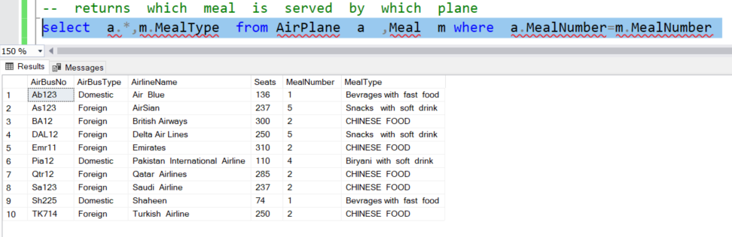

# --2

-- returns all the flights that are domestic

select * from Flight where AirBusNo in (select AirBusNo from AirPlane where Airplane.AirBusType='Domestic');

# 

# --3

-- returns all the flights that are foreign

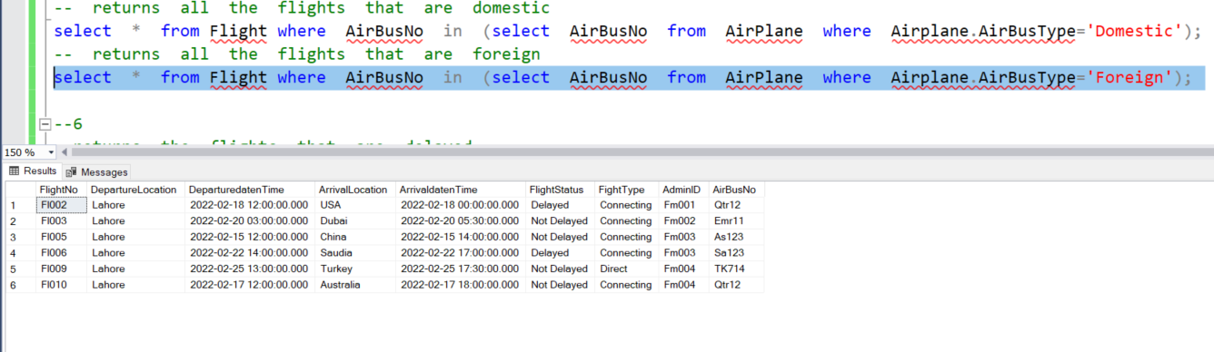select * from Flight where AirBusNo in (select AirBusNo from AirPlane where Airplane.AirBusType='Foreign');

# ---4

--returns the flights that are delayed

select * from Flight where FlightStatus='DELAYED'

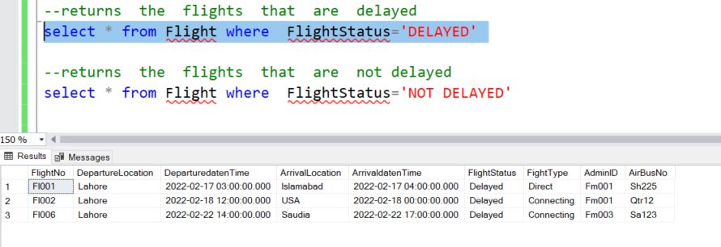

# --5

--returns the flights that are not delayed

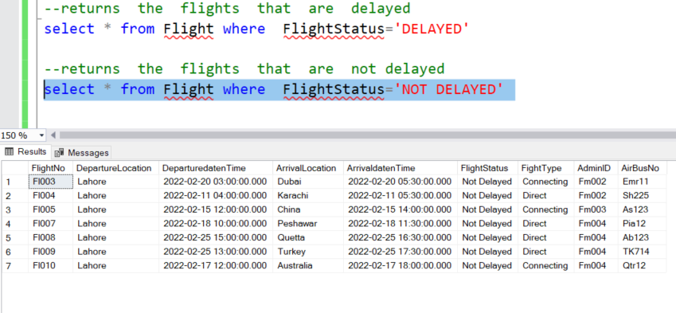select * from Flight where FlightStatus='NOT DELAYED'

# --6

-- returns how many flights are booked or paid

select RESERVATIONSTATUS, COUNT (*) AS ‘NO OF FLIGHTS’ from Travellers GROUP BY reservationStatus

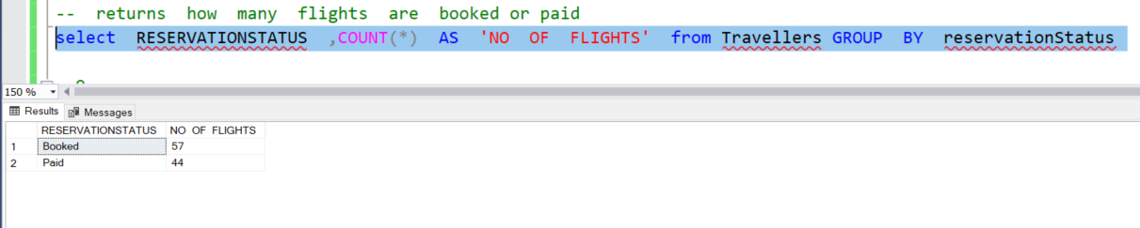

# --7

-- returns those travllers who are from lahore

select * from Travellers where address LIKE ‘%LAHORE%' ORDER BY reservationStatus

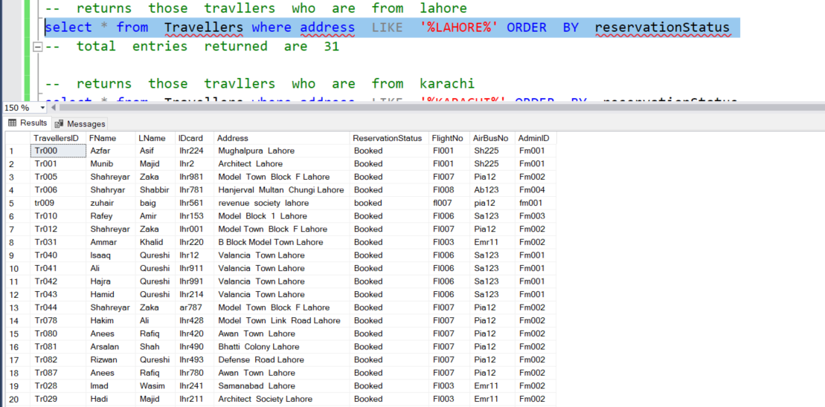-- total entries returned are 31

# --8

-- returns those travllers who are from karachi

select * from Travellers where address LIKE ‘%KARACHI%' ORDER BY reservationStatus

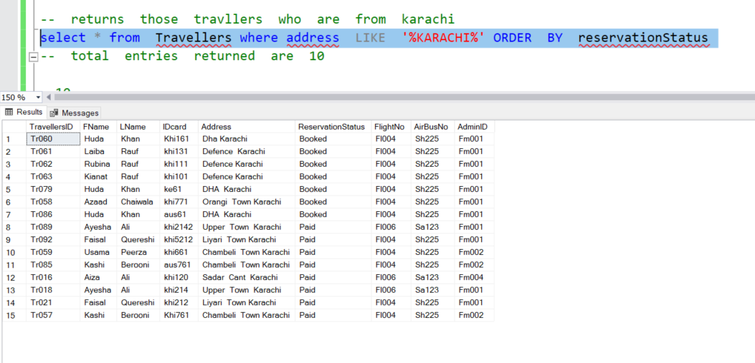-- total entries returned are 10

# --9

--return those flight which are departuring on 18 feburary

select * from Flight where day (DeparturedatenTime) ='18'

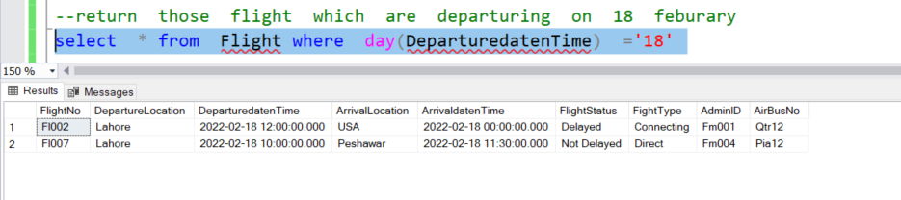

# --10

--return which admin is managing the specific travller

select * from FlightManager where AdminID= (select AdminID from Travellers where TravellersID ='Tr078')

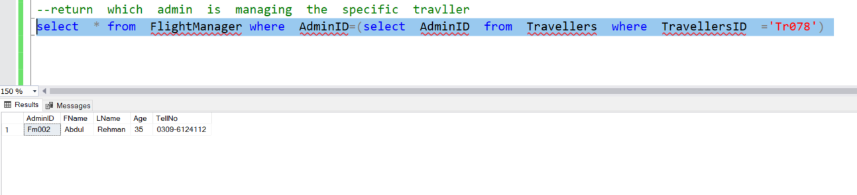

CHAPTER 7

ERD

